MEYR Meyra-Ring 2

GmbH D-32689 Kalletal

 {{REF_NO}} |  |  | 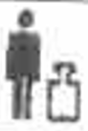  {{weight1}}
 {{SN_NO}}
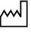 {{DATE}} |  |  |   {{weight2}}
Type {{Type_no}}
 | 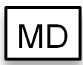 | {{barcode_image}}  {{barcode_number}}

